Section 1: Case Summary

Scenario Title:
Keywords: | Atrial Fibrillation, Tachy-Brady
Brief Description of Case: | 82-year-old female endorsing palpitations with a history of syncope. This case will progress through assessment and management of atrial fibrillation and tachy-brady syndrome. Learners will be required to apply atrial fibrillation guidelines, specifically around anti-coagulation.

Goals and Objectives
Educational Goal: | Improve practical application of atrial fibrillation guidelines and recognize complications that may alter management.
Objectives:  (Medical and CRM) | 1. Perform a focused history and physical exam for a patient presenting with palpitations.  2. Identify dysrhythmias and order appropriate investigations.  3. Apply current atrial fibrillation guidelines  4. Recognize complicated presentations of A-Fib and involve consultants when necessary.
EPAs Assessed: | TD1, TD3, F1, C5, C6

Learners, Setting and Personnel
Target Learners: | ☒ Junior Learners |  | ☒ Senior Learners |  |  | ☐ Staff
 | ☒ Physicians | ☒ Nurses |  | ☐ RTs | ☐ Inter-professional
 | ☐ Other Learners:
Location: | ☒ Sim Lab |  | ☐ In Situ |  |  | ☐ Other:
Recommended Number of Facilitators: | Instructors: 1
 | Sim Actors: 1
 | Sim Techs: 1

Scenario Development
Date of Development: | Feb 1, 2024
Scenario Developer(s): | Aneesha Thouli, Dr. Bradley Stebner
Affiliations/Institutions(s): | University of British Columbia
Contact E-mail: | athouli@student.ubc.ca  Bradley.stebner@alumni.ubc.ca
Last Revision Date: | March 9, 2024
Revised By:
Version Number:

Section 2A: Initial Patient Information

- Patient Chart
Patient Name: Edith |  |  | Age: 82 | Gender: F | Weight: 70kg
Presenting complaint: Palpitations
Temp: 36.2 | HR: 150bpm | BP: 110/70 | RR: 14 | O₂Sat: 98% | FiO₂: N/A
Cap glucose: 5 |  |  | GCS: 15
Triage note:
80 y/o female brought in by EHS for palpitations and dizziness.

Allergies:
Past Medical History:  Hypertension  DM2  Palpitations |  |  | Current Medications:  Ramipril  Insulin glargine  Insulin aspart  Metformin

Section 2B: Extra Patient Information

A. Further History
Include any relevant history not included in triage note above. What information will only be given to learners if they ask? Who will provide this information (mannequin’s voice, sim actors, SP, etc.)?

I was standing in the produce section and felt my heart racing and started to get dizzy, I was feeling fine prior. Once it started, I had to sit down but it didn’t go away. I thought it was just anxiety.

I’ve had palpitations lots over the past few months. I’ve been meaning to see the doctor about it but haven’t had a chance.

Denies chest pain, shortness of breath. If asked, patient will disclose 1 previous syncopal episode in the past month. She did not seek out medical care at that time as she thought it was dehydration and did not sustain any injuries.

No relevant FHx

B. Physical Exam
List any pertinent positive and negative findings
Cardio: Irregularly irregular pulses; pulses are palpable & strong x4. | Neuro: GCS 15; CN 2-12 normal; PEARL 2mm; normal motor and sensory function x 4 extremities.
Resp: Air entry equal bilaterally to lung bases. No crackles or wheezes. | Head & Neck: No evidence of head injury.
Abdo: Soft, non-distended with normal bowel sounds throughout. | MSK/skin: +1 pitting edema to lower legs bilaterally.
Other:

Section 3: Technical Requirements/Room Vision

A. Patient
☒ Mannequin (adult)
☐ Standardized Patient
☐ Task Trainer
☐ Hybrid
B. Special Equipment Required
C. Required Medications
Metoprolol
Apixaban

D. Moulage
E. Monitors at Case Onset
☐ Patient on monitor with vitals displayed
☒ Patient not yet on monitor
F. Patient Reactions and Exam
Patient will become increasingly dizzy following discussion of Afib management.
Patient will have increased dizziness corresponding to sinus pause on the cardiac monitor to prompt cardiology consultation.

Section 4: Sim Actor and Standardized Patients

Sim Actor and Standardized Patient Roles and Scripts
Role | Description of role, expected behavior, and key moments to intervene/prompt learners. Include any script required (including conveying patient information if patient is unable)
EMS | Gives background story:  Called to the scene for an elderly woman who was experiencing palpitations and dizziness. Pt was alert and able to communicate but felt lightheaded on ambulation and sat down until EHS arrived.  She reported the palpitations ongoing for ~15 minutes before our arrival with no relief.  Initial vitals: HR 160, BP 105/70, RR 12, O2 SAT 98%  Initial examination revealed irregular cardiac rhythm; otherwise, benign.  Arrived at the hospital prior to eliciting any other information.  No ECG strip was available from EHS.

Section 5: Scenario Progression

Scenario States, Modifiers and Triggers
Patient State/Vitals | Patient Status | Learner Actions, Modifiers & Triggers to Move to Next State |  | Facilitator Notes
1. Baseline State  Rhythm: Irregular  HR: 140bpm  BP: 110/75  RR: 14  O₂SAT: 98%  T: 36  GCS: 15 | Alert and oriented, laying in stretcher | Expected Learner Actions  Conduct a primary survey, identify irregular rhythm on cardiac monitor.  Obtain a focused history from patient.  Ask about PMHX, specifically cardiac risk factors and hx of syncopal episodes. | Modifiers  Triggers  - Identifies irregular rhythm on monitor -> 2. Initial evaluation | If learners do not elicit history of syncope, patient can spontaneously prompt them
2. Initial Evaluation  Rhythm: Irregular  HR: 140bpm  BP: 110/75  RR: 14  O₂SAT: 98%  T: 36  GCS: 15 |  | Expected Learner Actions  Discuss potential causes of AFib.  Order a 12-lead ECG.  Order initial labs to investigate potential triggers (CBC, lytes, Cr, TSH, hepatic panel, BNP, troponin, consider PE workup) | Modifiers  Triggers  - Initial investigations ordered -> 3. Diagnosis | Need to order investigations for possible causes of Afib.
3. Diagnosis  Rhythm: Irregular  HR: 150bpm  BP: 110/75  RR: 14  O₂SAT: 98%  T: 36  GCS: 15 | Patient becoming increasingly symptomatic. | Expected Learner Actions  Identify atrial fibrillation on 12-lead ECG.  Review labs, identify no abnormalities.  Discuss management strategies for Afib.  Identify contraindication to cardioversion (unless unstable, chest pain, heart failure etc) due to its chronic nature. | Modifiers  - Patient will begin complaining of dizziness with HR increase to 160bpm  Triggers  - Learners need to identify electrical cardioversion is contraindicated. Discuss alternative options for management including rate control and initiating anticoagulation +/- TEE to r/o clot. -> 4. Management | Team needs to have elicited that palpitations have been ongoing over a few months, making it long-standing Afib.
4. Management  Rhythm: Irregular  HR: 160bpm  BP: 110/75  RR: 14  O₂SAT: 98%  T: 36  GCS: 15 |  | Expected Learner Actions  Initiate anticoagulation therapy as per guidelines  Initiate rate control (Metoprolol 2.5-5mg IV bolus over 2 mins (q15mins up to 3 doses) or Diltiazem 0.25mg/kg IV over 10 mins  +/- inquire about TEE | Modifiers  - if rate control is initiated patient will report feeling better with HR drop to 120bpm after first dose  Triggers  - 2nd dose of rate control initiated -> 5. Tachy-Brady | TEE unavailable in ED
5. +/- Tachy-Brady  Rhythm: Irregular  HR: 120bpm -> 30bpm  BP: 110/75  RR: 14  O₂SAT: 98%  T: 36  GCS: 15 | Pt reports feeling lightheaded. | Identify presence of sinus pause on monitor.  Reassess patient and place defibrillator pads on  Discuss likely tachy-brady syndrome upon initiation of rate control.  D/C rate control.  Consult cardiology/CCU | Modifiers  - patient will be symptom free following 5s sinus pause  Triggers  - D/C rate control -> 6. Disposition | Sinus pause ECG shown when pt reports feeling dizzy.  New ECG on monitor screen in place of print out telemetry to ensure it is seen by the team at the appropriate time.
6. Disposition  Rhythm: Irregular  HR: 130bpm  BP: 110/75  RR: 14  O₂SAT: 98%  T: 36  GCS: 15 |  | Call cardiology for scheduled cardioversion +/- pacemaker.  Admit with telemetry | -> END CASE

Appendix A: Laboratory Results (all SI units)

CBC  WBC 7.4  Hgb 110  Plt 200  Lytes  Na 130  K 4.6  Cl 98  HCO₃ 10  Urea 6.0  Cr 100  Glucose 6  Extended Lytes  Ca 2.20  Mg 0.85  PO₄ 0.95  Albumin 38  TSH 4  VBG  pH 7.40  pCO₂ 40  pO₂ 65  HCO₃ 25  Lactate <1 | Cardiac/Coags  Troponin 38  INR 1.5  aPTT 25  Biliary  AST 15  ALT 21  GGT 15  ALP 75  Bili 5  Lipase 20  Tox (all undetectable)  EtOH  ASA  Tylenol  Dig level  Other  B-HCG N/A

Appendix B: ECGs, X-rays, Ultrasounds and Pictures

Afib on 12 lead ECG
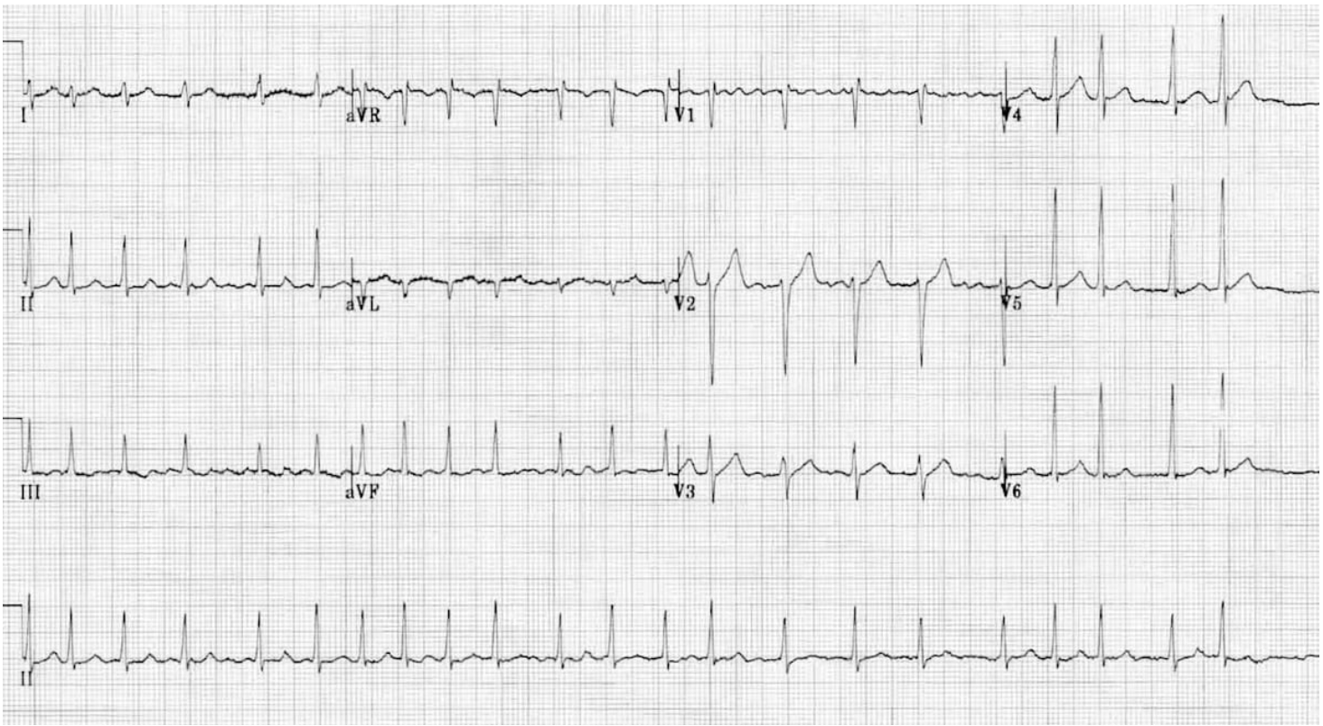
https://litfl.com/atrial-fibrillation-ecg-library/

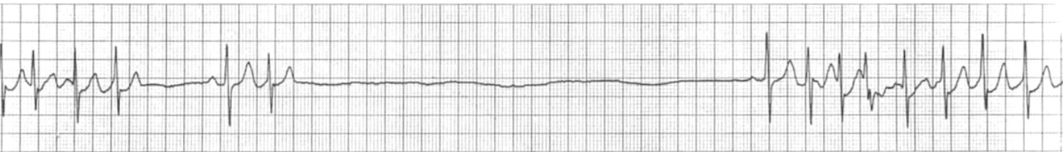
Sinus pause on monitor (tachy-brady syndrome)
https://litfl.com/sinus-node-dysfunction-sick-sinus-syndrome/

Appendix C: Facilitator Cheat Sheet & Debriefing Tips

Include key errors to watch for and common challenges with the case. List issues expected to be part of the debriefing discussion. Supplemental information regarding any relevant pathophysiology, guidelines, or management information that may be reviewed during debriefing should be provided for facilitators to have as a reference.

Questions for Discussion/Debrief

- What are possible reversible causes of Afib and what initial investigations would you order to rule these out?
- What are key ECG findings for Afib?
  - irregularly irregular, absent p waves, narrow complex
  - if rate is <150bpm and patient is hypotensive, it could likely be caused by something other than arrhythmia.
- Discuss approach to management of Afib.
a. stable vs unstable
b. rate control
c. rhythm control
d. anti-coagulation (CHADS2 score)
e. indications and contraindications for cardioversion
f. underlying causes that need to be considered
- Which patients are at risk of SA node dysfunction?

References

1. Platt, MA., & Price, TG. Heat Illness. In: Walls RM, Hockberger RS, Gausche-Hill M, Erickson TB, Wilcox SR, editors. Rosen’s Emergency Medicine: Concepts and Clinical Practice. [Internet]. 10th ed. Philadelphia (US): Elsevier; 2023. [cited 2023 Oct 2]. Chapter 11. Available from: https://www.clinicalkey.com/#!/browse/book/3-s2.0-C20181032357
2. Dobrzynski H, Boyett MR, Anderson RH. New insights into pacemaker activity: promoting understanding of sick sinus syndrome. Circulation. 2007;115(14):1921-1932.
3. Jason G Andrade, Martin Aguilar, Clare Atzema, et al. The 2020 Canadian Cardiovascular Society/Canadian Heart Rhythm Society Comprehensive Guidelines for the Management of Atrial Fibrillation. Can J Cardiol. 2020 Dec;36(12):1847-1948.
4. Dakkak W, Doukky R. Sick Sinus Syndrome. [Updated 2023 Jul 17]. In: StatPearls [Internet]. Treasure Island (FL): StatPearls Publishing; 2024 Jan-. Available from: https://www-ncbi-nlm-nih-gov.ezproxy.library.ubc.ca/books/NBK470599/?report=classic
5. Hussain S, Jerry C, Luck. Syncope And Atrial Fibrillation: Which Is The Chicken And Which Is The Egg? J Atr Fibrillation. 2015 Dec 31;8(4):1175. doi: 10.4022/jafib.1175. PMID: 27957219; PMCID: PMC5135178.
6. Buttner EBAR. Atrial Fibrillation [Internet]. Life in the Fast Lane • LITFL. 2023. Available from: https://litfl.com/atrial-fibrillation-ecg-library/
7. Buttner EBAR. Sinus Node Dysfunction (Sick Sinus Syndrome) [Internet]. Life in the Fast Lane • LITFL. 2021. Available from: https://litfl.com/sinus-node-dysfunction-sick-sinus-syndrome/

